The intent for the second graded exercise is to reinforce your understanding of problem exploration/formulation & model development, and to focus on:

* the role of feedback (c.f. webnotes on [FB Intro](https://d2l.pdx.edu/content/enforced/676153-OFFERING_SYSC-514-001_201801/feedback.htm?ou=676153). and [More on FB](https://d2l.pdx.edu/content/enforced/676153-OFFERING_SYSC-514-001_201801/MoreonFB.htm?ou=676153))
* [model specification & calibration](https://d2l.pdx.edu/content/enforced/676153-OFFERING_SYSC-514-001_201801/calibration.htm?ou=676153)
* Population in a region has an indigenous growth rate and a net migration rate (let's assume positive migration means people are moving into the region, increasing the population).
* The initial number of jobs in the region is equal to a value that is roughly consistent with the population (for example, half the population).
* When the jobs and population are "in balance," then net migration will be zero.
* If the ratio of jobs to population rises appreciably above this "ideal" ratio, then positive migration occurs.
* If the ratio goes below the ideal value then negative migration will occur.
* A parameter might be defined to represent the "avg. time to correct an imbalance." This parameter would be used to compute the amount of migration in a given time period, given the size of the imbalance. One approach might be to define a constant that represents the ideal ratio of people to jobs (perhaps 2), and then define the "ideal population" to be jobs times this ideal ratio.

Now compare actual population to the ideal population. Let's say the ideal ratio would suggest that there should be 1,000,000 people in the region, given the number of jobs (perhaps 500,000), but in reality there are only 970,000 people (an imbalance of 30,000). This would imply that 30,000 people should move into the area. If the avg. time to correct is 3 [years], then 30,000/3=10,000 people would move in the first year that such an imbalance existed.

Build a model based at least loosely on these concepts, with jobs as a "driver" variable (I would treat it as a stock, with an inherent growth rate). Population would adjust to try to achieve the proper balance. Study its behavior with different initial conditions and parameter values. In general, population should "chase" jobs. One possible behavior:

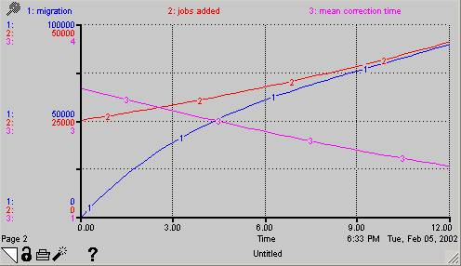

* As time permits, add avg. wage rates to the model and create relationships to show how they would be affected by the sign and the size of the imbalance at any point in time...and how this would in turn affect the migration rates (via the avg. time to correct an imbalance parameter, which would no longer be a constant).

One possible reference behavior pattern for this part is included below. Remember, the goal of this exercise is NOT necessarily to construct a model that duplicates the specific behavior shown below--this is only one example of possible valid responses. Your own results will depend strongly on the assumptions you make and the approach you take. **Be sure to document your approach(es) and assumptions, and comment on how these might have produced the actual model behavior you observe.**

